User Manual

The user can interact with the program at the bottom of the Main class in the main method.

There are two Strings labeled player1 and player2 that can be any of the names from the list below. Also, there is an int value called numHops that allows the user to find the number of players that are within a certain number of connections away from the source node. The user can manipulate any of these three values.

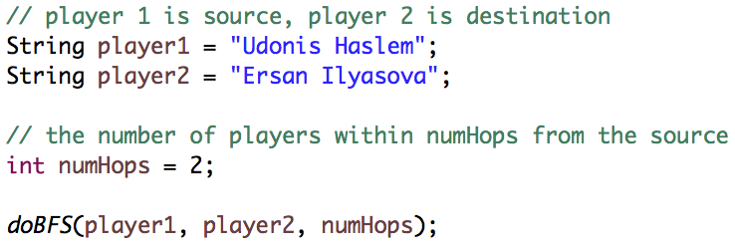

The program will output the distance from player1 to player2, with player1 being a distance of 0 from himself, being on a team with player1 is a distance of 1, and so forth. The program will also output the path of players taken to reach player2. Depending on the numHops value, the program will return the number of players who are within a distance of numHops from player1. Finally, the program will return the maximum distance from player1 in the graph.



List of Potential Players:

Arron Afflalo

Alexis Ajinca

LaMarcus Aldridge

Tony Allen

Alan Anderson

Ryan Anderson

Carmelo Anthony

Trevor Ariza

Darrell Arthur

D.J. Augustin

J.J. Barea

Nicolas Batum

Jerryd Bayless

Michael Beasley

Marco Belinelli

Andrew Bogut

Corey Brewer

Aaron Brooks

Bobby Brown

Jose Calderon

Vince Carter

Mario Chalmers

Tyson Chandler

Wilson Chandler

Josh Childress

Nick Collison

Mike Conley

Jamal Crawford

Luol Deng

Goran Dragic

Jared Dudley

Kevin Durant

Raymond Felton

Channing Frye

Danilo Gallinari

Marc Gasol

Pau Gasol

Rudy Gay

Manu Ginobili

Eric Gordon

Marcin Gortat

Gerald Green

Jeff Green

Devin Harris

Udonis Haslem

Spencer Hawes

Nene Hilario

George Hill

Al Horford

Dwight Howard

Andre Iguodala

Ersan Ilyasova

Jarrett Jack

LeBron James

Al Jefferson

Richard Jefferson

Amir Johnson

Joe Johnson

DeAndre Jordan

Kyle Korver

Kosta Koufos

Courtney Lee

Shaun Livingston

Brook Lopez

Robin Lopez

Kevin Love

Kyle Lowry

Ian Mahinmi

O.J. Mayo

Luc Mbah a Moute

JaVale McGee

Josh McRoberts

C.J. Miles

Paul Millsap

Anthony Morrow

Jameer Nelson

Joakim Noah

Dirk Nowitzki

Emeka Okafor

Zaza Pachulia

Tony Parker

Chris Paul

Kendrick Perkins

Ronnie Price

Zach Randolph

J.J. Redick

Sergio Rodriguez

Rajon Rondo

Derrick Rose

Brandon Rush

Thabo Sefolosha

Ramon Sessions

J.R. Smith

Jason Smith

Josh Smith

Marreese Speights

Jason Terry

Anthony Tolliver

P.J. Tucker

Sasha Vujacic

Dwyane Wade

C.J. Watson

David West

Russell Westbrook

Damien Wilkins

Lou Williams

Marvin Williams

Brandan Wright

Nick Young

Thaddeus Young